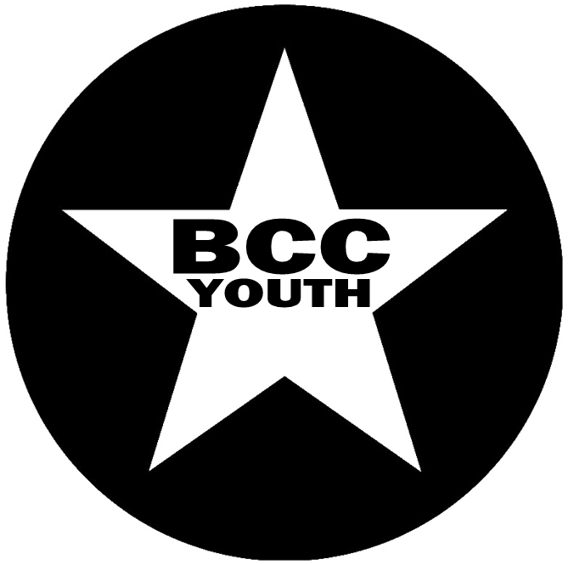
PARENTAL CONSENT FORM

Young Persons Part
Name:
Address:
Postcode:
Email:
Mobile number:
Date of birth:
I would love come along BCC Youth. I agree to abide by the instructions of the Youth team.

Signed : ………………………………………………………… Date: …………………………

Parent/Guardian Part
Parent/guardian name(s):
Address (if different from above):
Postcode:
Email(s):
Home telephone number(s):
Mobile number(s):
Other emergency contact (24 hrs):
Medical requirements:
Dietary needs:
Allergies:
Doctor’s name:
Doctor’s phone number:
I agree to …………………...….……… attending BCCC Youth activities and entrust them to the leaders’ responsible care. I understand for outdoor/social activities that they will be travelling by car/minibus

I give my permission for the leaders or venue staff to treat my child for minor medical needs, including administration of pain medication (such as Paracetamol and Ibuprofen) as needed.

I have described any relevant medical, dietary and allergy details above. In case of an emergency, I can be contacted at the number(s) above.

Signed : ……………………………………… (parent/guardian) Date: …………………………

PLEASE RETURN THIS SLIP TO ALI CROMPTON, BCC YOUTH, 49a SATURDAY MARKET, HU17 8AA
OR E-MAIL TO: INFO@BCCYOUTH.INFO

WE OPERATE AN OPT OUT POLICY ON PHOTO/VIDEO – PLEASE INDICATE IF YOU DO NOT WISH YOUR CHILD TO APPEAR ON MULTIMEDIA (WHICH WILL BE USED ONLY FOR PUBLICITY AND NOT SHARED)

